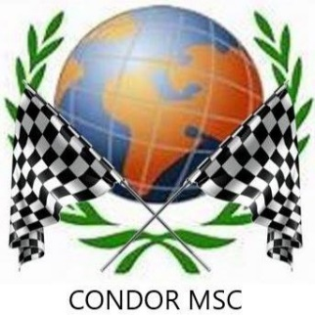

BACK TO ROOTS TARMACK CHAMPIONSHIP 2023
Saturday 25th March 2023 saw the running of the 2nd round of the Back to Roots Tarmack Championship for 2023.
Organised by Condor MSC at RM Condor, Arboath, the Memorial Garden Stages had it’s biggest entry to date with 17 drivers and codrivers from the Championship taking part!
Most improved on seeding on the day were Stuart Waite and Lisa Demirkoc in the Peugeot 106 gaining a very impressive 10 places and ending up 17th overall and 4th in class. They win the pair of Mintex brake pads generously donated by Championship sponsor Questmead. https://www.questmead.co.uk/
The next round of the Championship is 30th April in Leconfield – the Rainworth Skoda Stages Rally orgainsied by Sheffield and Hallamshire Motorclub. The link to the entry form is https://www.rallies.info/webentry/2023/rainworthskoda/webentry.php

